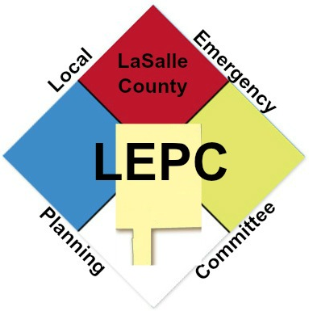
LaSalle County
Local Emergency Planning Committee (LEPC) Meeting
November 1, 2022, 11:00am
Minutes

Attendees:
Lou Silver & Damien Mangabhai- Coogee Ottawa
Fred Moore & Corban Flynn – LaSalle County Emergency Management Agency
Chris Pozzi – Health Department
Amanda Los – OSF Healthcare
Brian Bressner – Ottawa Fire
Sarah Suepfert – St. Margaret’s Peru.

Meeting was called to order at 11:00am.

Old Business
July 5th 2022 LEPC Meeting Minutes: Unable to vote due to no Quorum

Tier II Update

 |  | FOID Request August-September 2022
Date Reported | Location (City) | Substance | Response | Response Date
09/27/22 | Verdantas | 2796 N. 21st Road | No Info on File-Directed them to IEMA Website | 09/28/2022
09/29/22 | Verdantas | 2796 N. 21st RD | No Info on File-Directed them to IEMA Website | 10/03/22

There were Two FOIA requests received listed above

HMEP Grant Updates
No Updates

LEPC Support Update –
$2,100 has been received in donations so far for the full-scale exercise which takes place in September or October of 2023

Citizen Corps
- Medical Reserve Corps (MRC) – No Updates

New Business

Plant/Pipeline/LaSalle Peru Utica Community Advisory Panel (LPU CAP) Updates
- Cooge– Opening soon, they are working with the city and 3rd party inspections and are working on their ERP.
- Health Department – No Updates
- Hospitals – No Updates

Election of LEPC Chairman – Due to Brandon Lewis accepting a new position down state the LEPC is looking for a new Chairman. The Election has been tabled for our next meeting.

Full Scale Exercise- Our Full scale is set to take pace at the end of 2023. Sabic has stepped forward as the host facility.

LEPC Plan Review- None

Public Comment – None

Next Meeting January 3rd, 2023 @ 11:00am

Meeting Adjournment @ 11:45am.

Respectfully,
Corban Flynn
Corban Flynn
LEPC Secretary
LaSalle County Emergency Management Agency Deputy Director

